MEDICAL COAT PLUS INVENTORY SYSTEM USER MANUAL

Initial Setup Guide
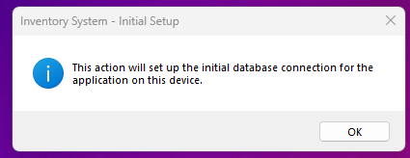

After installing the Inventory System, the Admin must first configure the database connection.
Once connected:
- Log in using the Admin account.
- Go to Settings.
- Set up the Store.
- Click Save to apply changes then logout.
The system is now ready to use.

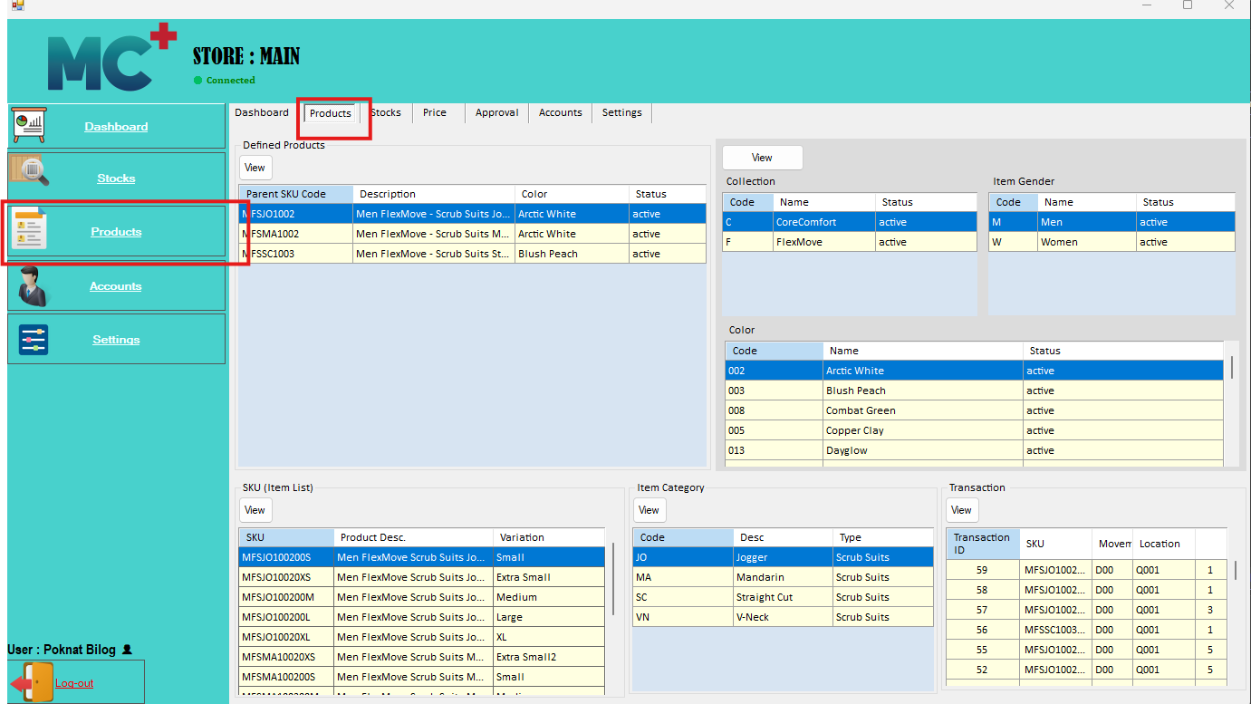
Product Tab
The Product Tab allows users to manage and view product-related data within the system. This module provides access to product items, collections, gender classifications, colors, categories, SKUs, and transaction history. It also supports the creation and updating of product definitions and related records.

  - Prerequisites Before Creating a Product
Before creating a product, the user must ensure that all required product reference data is properly defined and complete. Accurate setup of these details is necessary to ensure correct product classification and variant generation within the system.
The user must clearly define the following product information:
- Gender – Specifies the target gender classification of the product (e.g., Male, Female, Unisex).
- Collection – Refers to the fabric or product collection grouping to which the item belongs.
- Color – Defines the available or assigned color of the product.
- Product Type – Indicates the general category of the product (e.g., Scrub Suits, Caps, Medical Coats).
- Style Category – Defines the style classification under a product type (e.g., Mandarin, V-Neck, etc.).
- Style Variant – Specifies the variation under a style category (e.g., Scrub Suit Mandarin may include variants such as with zipper or buttons).
- Variation– Defines the product variations such as size, or other distinguishing characteristics that differentiate each SKU.
All the above prerequisites must be properly configured before proceeding with product creation and variant setup.
Managing Gender, Collection, and Color
To access these modules:
- Navigate to the Product Tab.

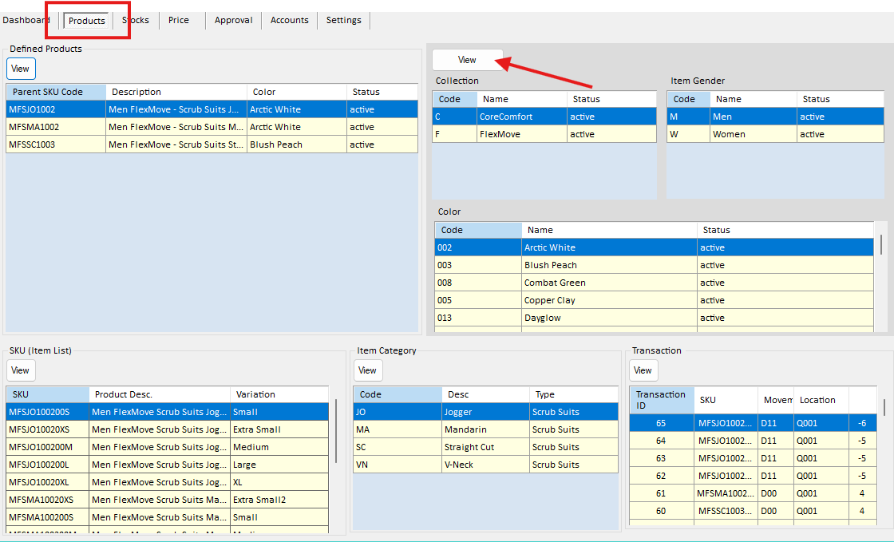
- Click the View button. See the picture below

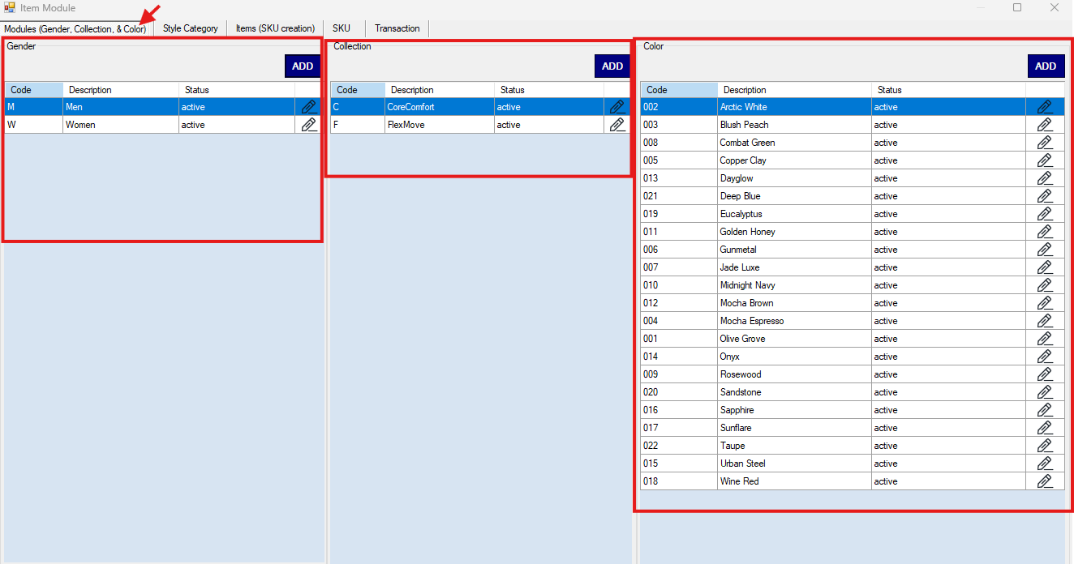
- The system will display the lists for Gender, Collection, and Color.

Creating a Gender
To create a new Gender entry:
- Go to the Product Tab.
- Click Gender, Collection & Color.
- Under the Gender section, click the Add button.
- Enter the required details:
  - Code
  - Description
  - Status
- Click Add to save the new Gender.

Creating a Collection
To create a new Collection:
- Navigate to the Product Tab.
- Click Gender, Collection & Color.
- Under the Collection section, click the Add button.
- Enter the required details:
  - Code
  - Description
  - Status
- Click Add to save the new Collection.

Creating a Color
To create a new Color:
- Go to the Product Tab.
- Click Gender, Collection & Color.
- Under the Color section, click the Add button.
- Enter the required details:
  - Code
  - Description
  - Status
- Click Add to save the new Color.
Note: The Code field is non-editable; only the Description and Status of Gender, Collection, and Color can be modified after creation.

Managing Product Type, Style Category, and Style Variant
The Product Type, Style Category, and Style Variant are hierarchical components used to define product structure within the system. These must be configured in sequence before creating products.

Structure Overview
- Product Type – Represents the main category of the product (e.g., Scrub Suits, Caps, Medical Coats).
- Style Category – Defines the style classification under a Product Type (e.g., Mandarin, V-Neck).
- Style Variant – Specifies the variation under a Style Category (e.g., with zipper, with buttons).
Note:
The Wear Type is associated with the Style Category. It is used for classification purposes only and is not included in the SKU code generation.
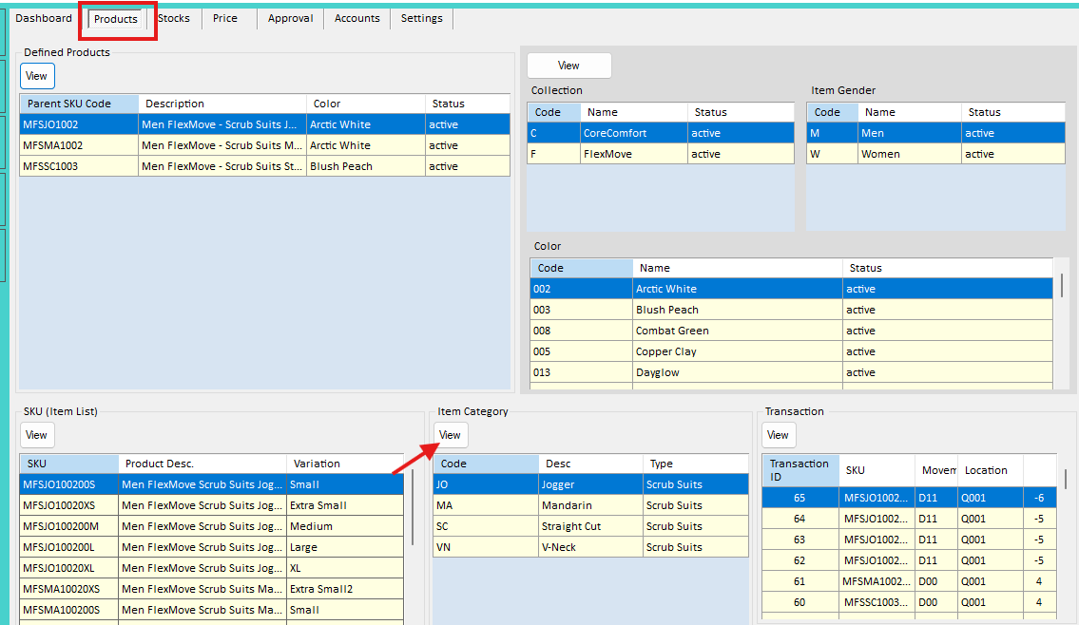
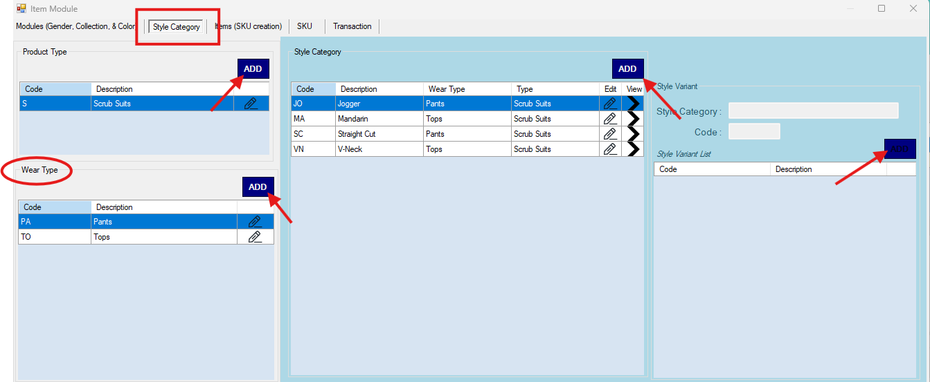
To access the module, Navigate to the Product Tab > Click button View under Item Category.

Creating a Product Type
To create a Product Type:
- Click the Add button.
- Enter the required details:
  - Code
  - Description
- Click Add or Submit to save the record.

Creating a Style Category
To create a Style Category:
- Click the Add button.
- Enter the required details:
  - Code
  - Description
  - Wear Type - Select from the dropdown list. If the required Wear Type is not available, it must be created first before proceeding.
  - Product Type - select from the dropdown list
- Click Add or Submit to save the record.

Creating a Style Variant
To create a Style Variant:
- Click the Add button.
- Enter the required details:
  - Code
  - Description
  - Style Category (select from the dropdown list)
- Click Add or Submit to save the record.

  - Defining a Product and Generating SKU
The Define Product module is used to create product records and generate unique SKUs (Stock Keeping Units) for each item. Before proceeding, ensure that all required prerequisites (e.g., Gender, Collection, Color, Product Type, Style Category, and Style Variant) have been properly configured.
Once all necessary data is defined, the user may proceed with creating the Parent SKU and its corresponding item variants.
Accessing the Defined Products Module
To access the product definition screen:
- Navigate to the Product Tab.
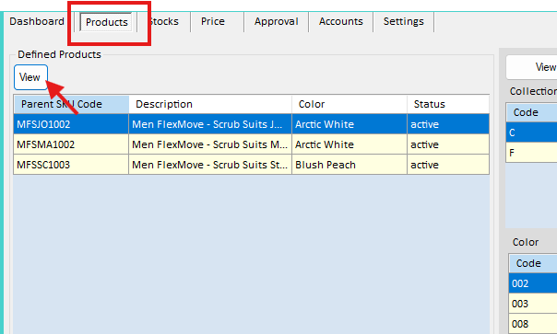
- Under Defined Products, click View.
- The system will display the list of existing Parent SKUs.
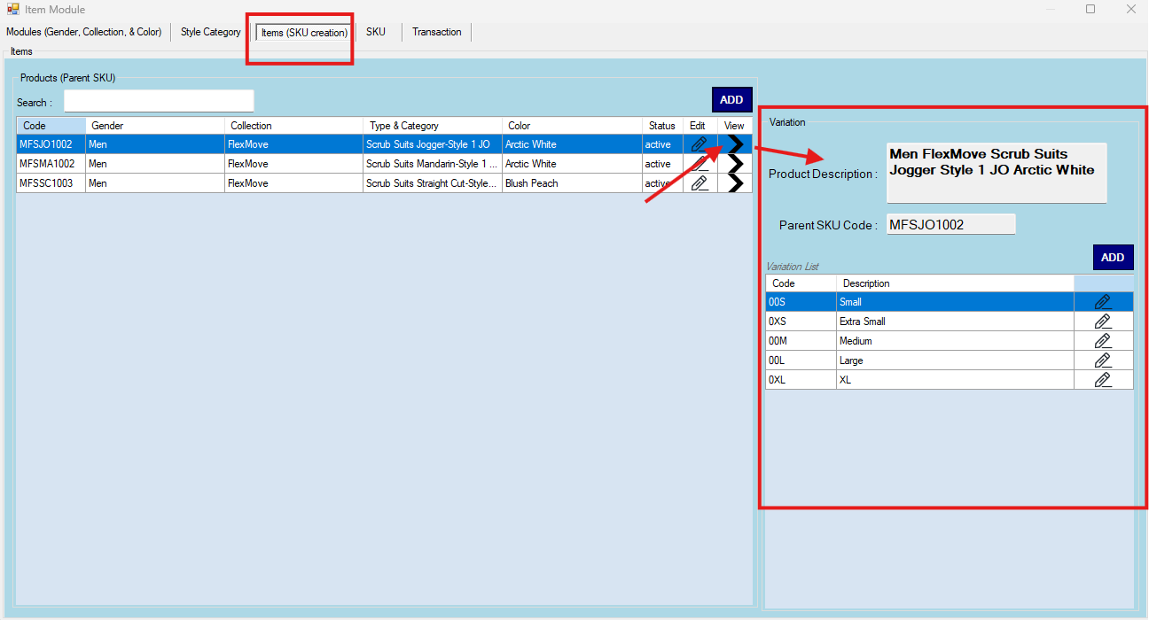
- To view item variations, click the View button on a selected Parent SKU record.

Creating a Parent SKU
A Parent SKU must be created first before generating item-level SKUs (variants).
To create a Parent SKU:
- In the Defined Products module, click the Add button under Parent SKU.
- Complete the required fields (all fields are selected via dropdown lists):
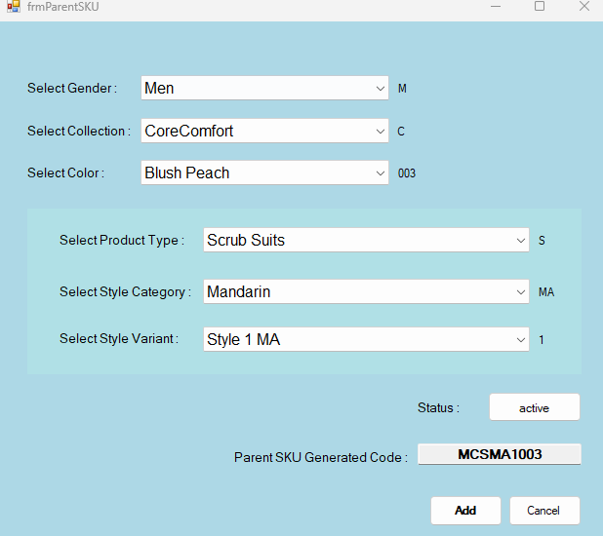
  - Gender
  - Collection
  - Color
  - Product Type
  - Style Category
  - Style Variant
  - Status

- Set the Status to Active during creation.

Note : Field Behavior and System Logic
- Selecting a Product Type will automatically filter the available options in the Style Category dropdown.
- Selecting a Style Category will automatically filter the available options in the Style Variant dropdown.
- The Parent SKU Code is automatically generated by the system and is non-editable.
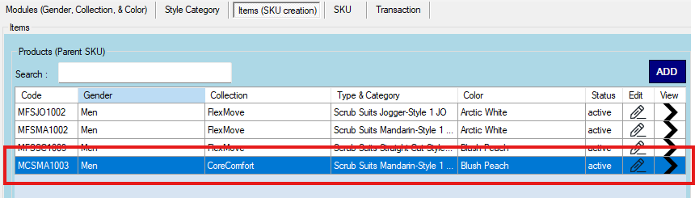
- After completing all required fields, click Add to save the Parent SKU.

Creating Item Variants (SKU per Item)
After successfully creating a Parent SKU, users may proceed to define the specific item variations (e.g., size-based SKUs).
Accessing Variations
- Navigate to the Defined Products module under the Product Tab then click View.
- Locate the desired Parent SKU.
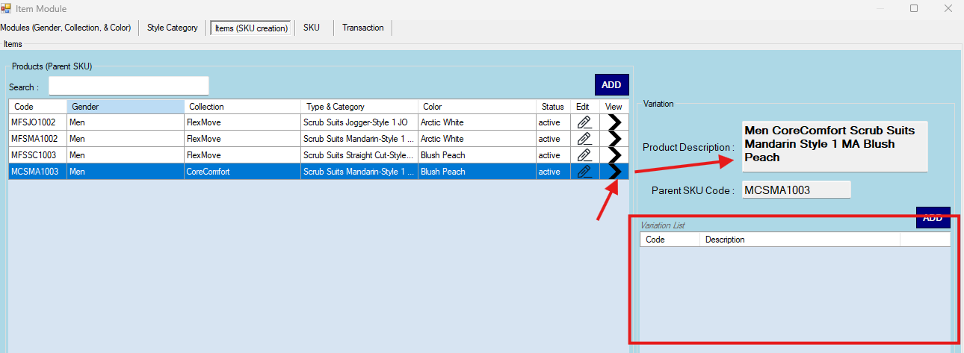
- Click the button on the same row to display its existing variation list (if any).

Adding a New Variation
To create a new item variation:
- In the Variation List, click the Add.
- Enter the Variation Description (e.g., Small, Medium, Large).
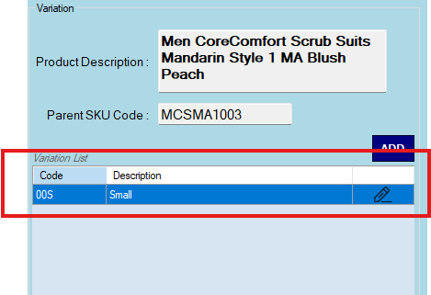
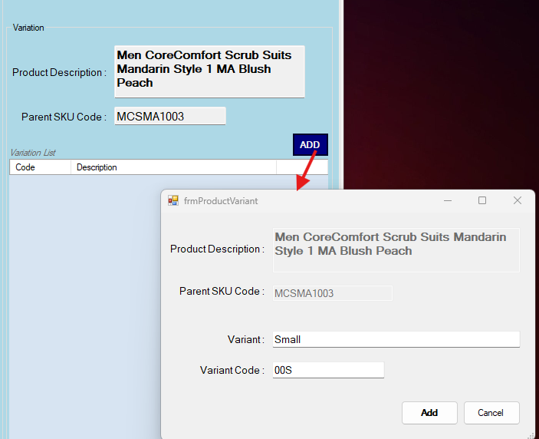
- Click Add to save the new variation.

Once variations are created, the system will generate the corresponding item-level SKUs based on the defined Parent SKU and variation attributes.
Data Processing and Visibility
After defining a product item or SKU, the data will not be immediately visible in other modules.
Please note the following:
- Newly created products or SKUs are processed by the system and will automatically become visible in the SKU List, Item Price, and Item Balance modules after the daily system data update at 12:00 midnight.
- If immediate visibility is required, the user may request assistance from the IT Administrator to manually trigger the process (For IT : Go to settings for manual trigger).

Viewing the Item/SKU List
Users can view a quick list of all items and their corresponding SKUs, along with key details such as price and stock levels.
To access the Item/SKU list:
- Go to the Product tab.
- Click the SKU (Item List) View button.
- The system will display the list of all items and SKUs, including their basic details such as:
  - Item Name / SKU
  - Price
  - Stock Balance
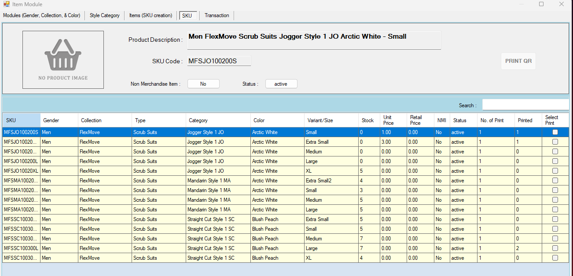
  - Other relevant information
This section gives users a quick overview of all products without needing to open each item individually.

Stocks Tab
The Stocks tab allows users to monitor and manage inventory across the system. Go to Stocks Tab
Within this tab, users can perform the following:
- View Actual Stocks – Check the current stock levels of items.
- View Stocks per Location – See stock distribution across different locations.
- Manage Suppliers – Access and review the list of suppliers.
- Transfer Stocks – Process stock transfers between warehouses (stock in and stock out).
- Receive Purchase Orders (PO) – Receiving items from approved purchase orders delivery.
- Manual Receiving – Enter and record stock received without a system-generated purchase order.
This tab serves as the central module for tracking inventory movement and ensuring accurate stock levels across all locations.
View Stocks and Locations
Allows users to monitor item stock and identify the specific location where each item is stored.
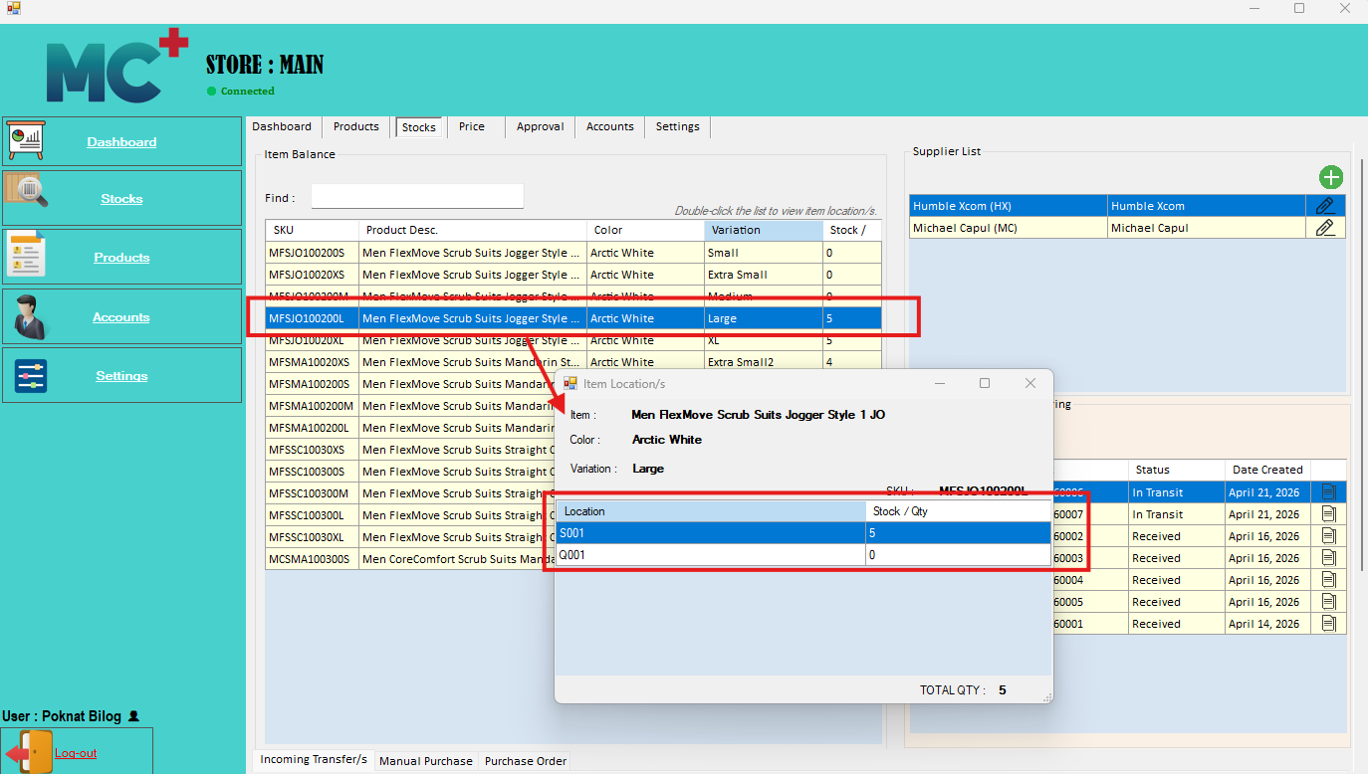
In the Stocks Tab, users can view the total stock of each item. By double-clicking a specific item row, the system will display a detailed breakdown of stock per location.
    - View and Manage Supplier List
Allows users to view, create, and update supplier information in the system. Users can also access the supplier list to see all registered suppliers and their details.
The system also allows the following actions:
- View Supplier List – Display all existing suppliers and their information.
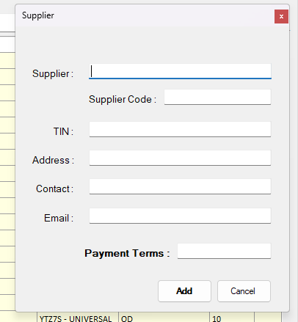
- Create Supplier – Click and Add a new supplier by entering the required details.
- Update Supplier Details – To modify a supplier, click this button in the same row of the selected supplier.

    - Outgoing Transfer (Stock OUT)
Outgoing transfers refer to stock movements from one store or warehouse to another. This process follows a status-based workflow to ensure proper approval, picking, delivery, and receiving.
Create Transfer
To create a stock transfer, follow these steps:
- Click the Outgoing Transfer/s button.
- Navigate to Transfer Creation.
- This screen allows you to create a list of items that need to be transferred. 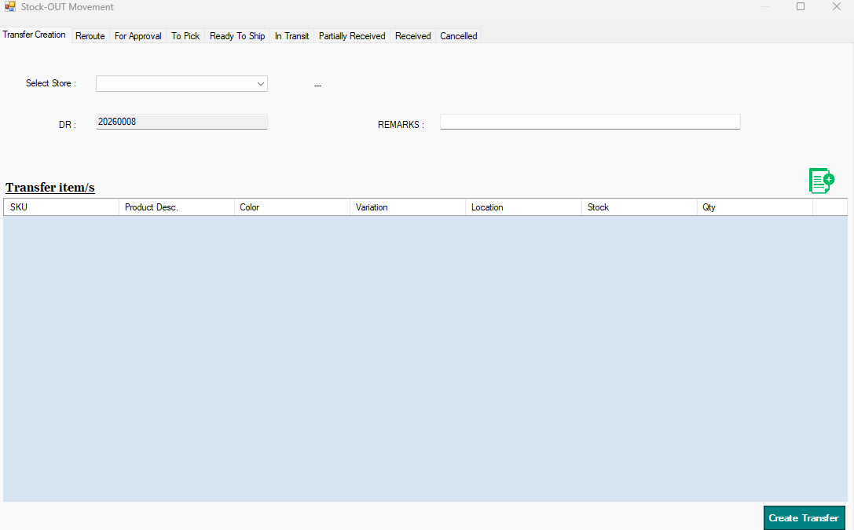
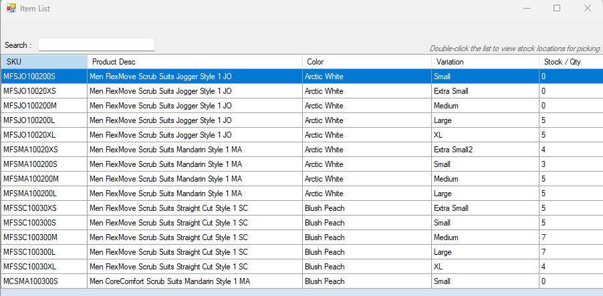

- Click the button to view all available items for selection.

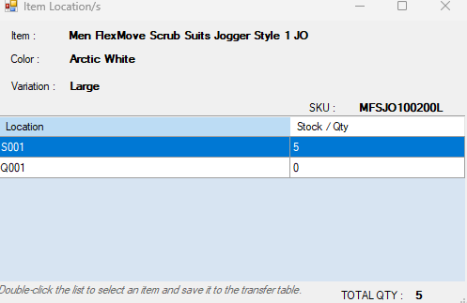
- From the item list, double-click the desired item row in the Data Grid. The system will display the selected item’s stock per location.
- Double-click the item with the specific location to add it to the transfer list.
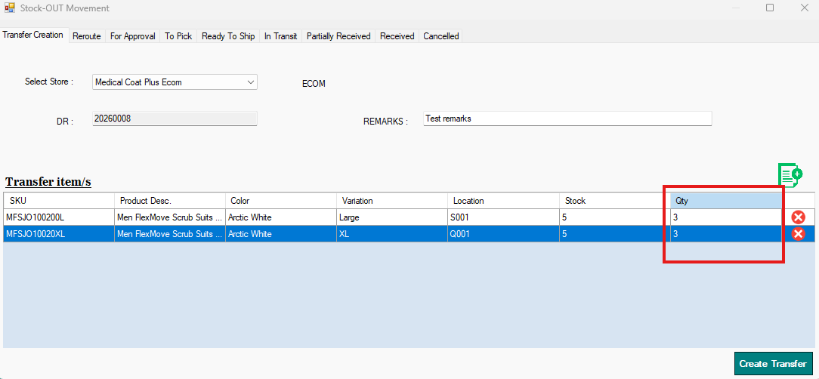
- Input the quantity in the same row of the selected item with location.
- Once all required items and fields are complete, click the Create Transfer button to save and submit the transfer request.

Transfer Status Flow
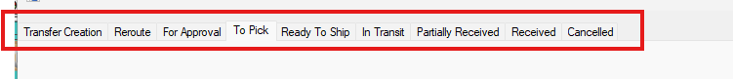
- Reroute (10)
The transfer can be moved to Reroute status if modifications are needed at any stage (from For Approval up to Ready to Ship).
This is used when there are changes such as incorrect items or quantity adjustments. Once rerouted, the transfer will be reprocessed and returned to For Approval status for review and approval.
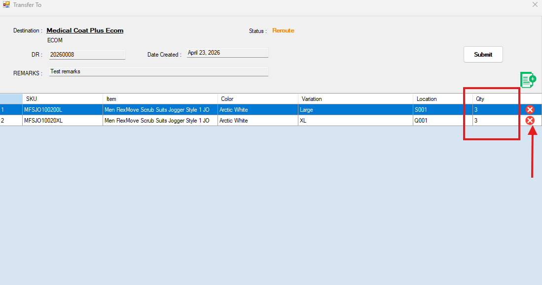
How to Modify Transfer (Reroute)
When a transfer is in Reroute status, users can update the item list or quantities as needed.
To modify the transfer:
Update Quantity
  - Locate the item in the list.
  - Change the quantity directly in the input field within the same row.
Delete an Item
  - Find the item you want to remove.
  - Click the button in the same row to remove it from the list.
Add a New Item

  - Click button.
  - Select an item from the list.
  - A pop-up will display available locations.
  - Choose the desired location to add the item to the transfer list.
Once all changes are completed, review the updated list.
Click the Submit button to resubmit the transfer for approval.

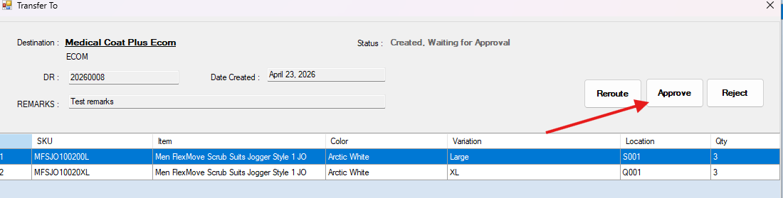
- For Approval (0)
After creating a transfer request with an item list, it will appear under this status. Only RPT and ADM Users are allowed to approve the transfer.
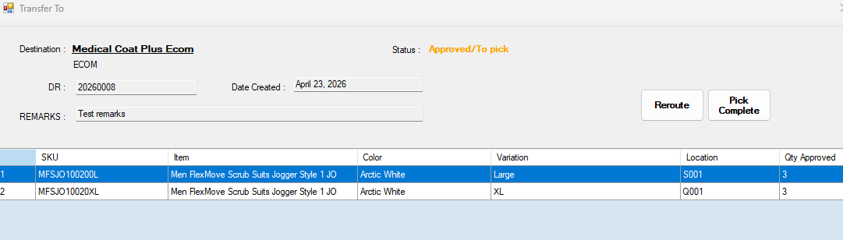
- To Pick (1)
Once approved, the transfer moves to the picking stage. The assigned user or employee must pick the listed items in their location.
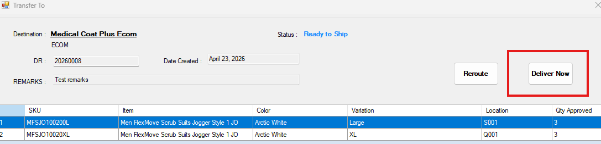
- Pick Complete / Ready to Ship (2)
After all items are successfully picked, click the Pick Complete button. The transfer status will then change to Ready to Ship. If not complete, reroute the transfer.

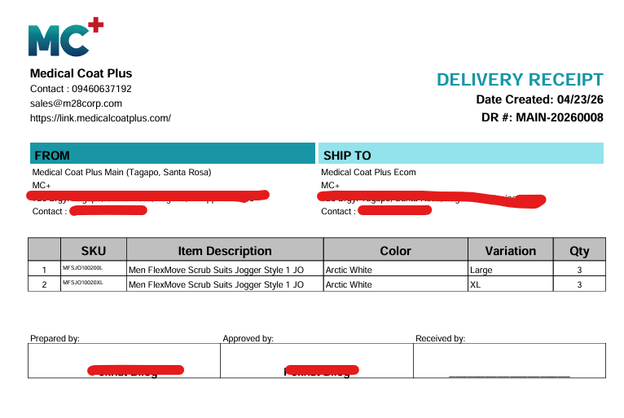
This action can also the delivery receipt
- In Transit (3)
Once the transfer is ready, the Delivery Receipt (DR) is printed. After printing, the transfer is moved to In Transit status.
- Cancelled (9)
The transfer will be marked as Cancelled if it is not approved or if it is rejected during the approval process.
Receiving Statuses
The following statuses can be viewed during the receiving process:
- In Transit (3) – Items are currently being delivered.
- Partial Receive (3) – Only part of the items has been received. The status is still No. 3 if it was received but not complete.
- Received (4) – All items have been successfully received.
Note: Only the receiving user is allowed to trigger status changes during the receiving process.

    - Receiving Incoming Transfers (Stock IN)
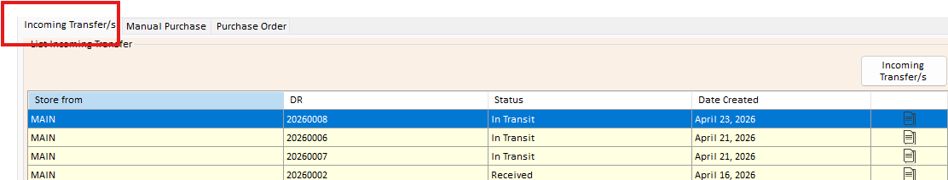
This section displays all incoming transfer Delivery Receipts (DR), with all statuses listed for easy viewing and processing.
To access incoming transfers:
- Click the Incoming Transfer/s button.
- A new window will appear displaying all incoming transfer records and their statuses.
Incoming Transfer Statuses
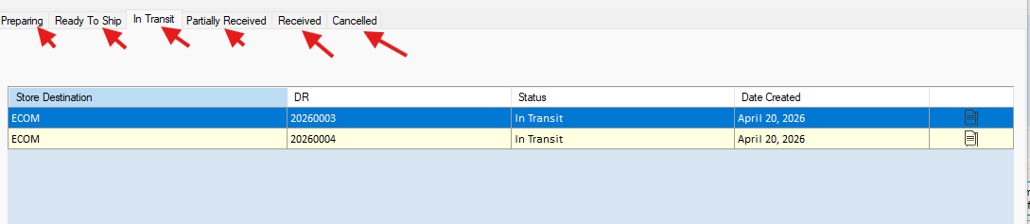
Users can view transfers under the following statuses:

- Preparing – Items are still being prepared by the sending store.
- Ready to Ship – Items are ready for dispatch.
- In Transit – Items are currently being delivered.
- Partial Receive – Some items have been received, but not yet complete.
- Received – All items have been successfully received.
- Cancelled – The transfer has been cancelled.
How to Receive Items
To receive items from an incoming transfer:
- Go to the In Transit tab.
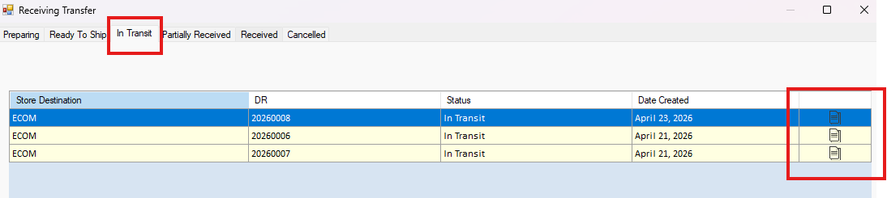
- Select the Delivery Receipt (DR) you want to receive.
- Input the received quantity for each item in the same row.
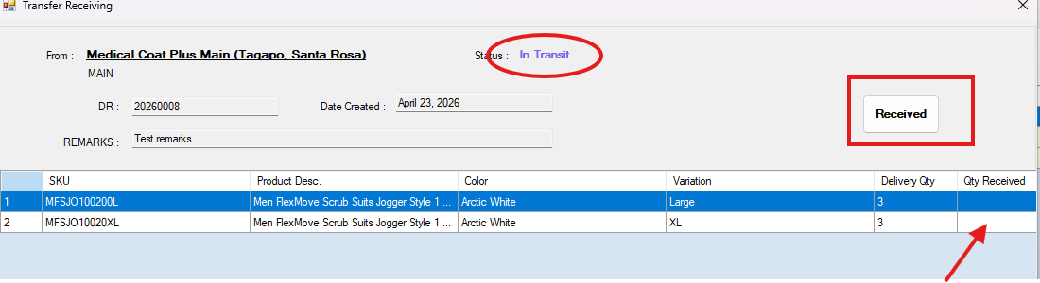
- Click the Receive button to confirm.

Partial Receiving and Complete Receiving
- If the received items are incomplete, the transfer will move to Partial Receive status. In this status, users can continue receiving the remaining items once they arrive.
- Once all items are fully received, the transfer status will automatically update to Received.

    - Manual Purchase (Stock IN)
In Manual Purchase, users can receive items that are purchased without a Purchase Order (PO) and record them as stock in the system.
How to Receive via Manual Purchase
To receive items using the Manual Purchase feature, follow these steps:
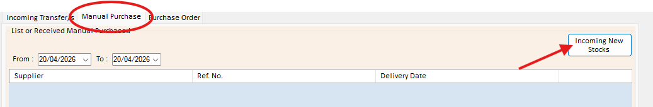
- Click the Incoming New Stocks button.
- Fill in the required details:
  - Supplier (Add a supplier first if it does not exist)
  - Reference Number
  - Receipt Date
  - Delivery Date
  - Remarks


- Click button to display the list of available items.
Note: If the item is not yet in the system, you must create the corresponding product/SKU first before proceeding.
- From the item list, double-click the desired item.
  - The selected item will automatically be added to the stock-in list.
- Enter the following details in the same row:
  - Quantity
  - Unit Cost
- To remove an item from the list (if added by mistake), click the button in the same row.
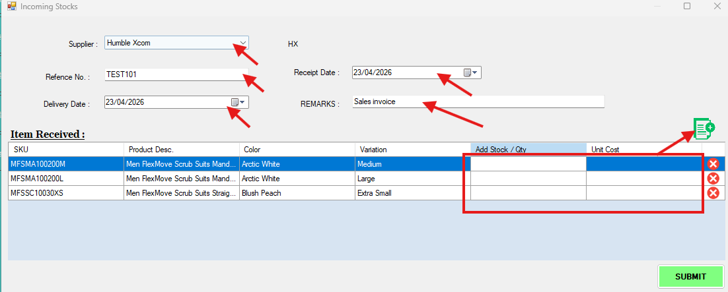
- Once all items and details are complete, click Submit to proceed with stock-in.
Note: All items received through Manual Purchase will automatically be stocked in the default location “Q001.”

    - Receiving Purchase Order (Stock IN)
This module is used for receiving items from open Purchase Orders (PO) that have been created and approved in the system.
It allows users to record and received incoming stocks based on the PO details and update inventory accordingly.
How to Receive a Purchase Order (PO)
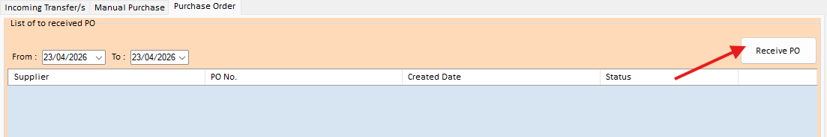
To receive items from a Purchase Order, follow these steps:
- Click the Receive PO button.
- A pop-up window will appear displaying different status tabs.
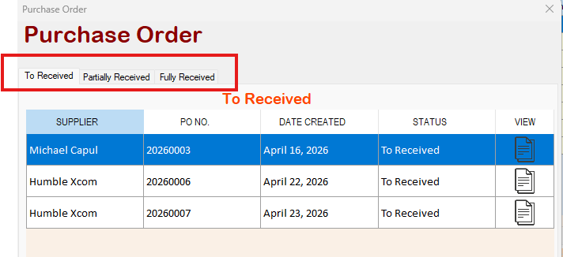
PO Status Tabs
- To Receive
Displays the list of all receivable (open) Purchase Orders.
- Partially Received
Shows Purchase Orders with incomplete deliveries. Users can continue receiving the remaining items to complete the PO.
- Fully Received
Displays Purchase Orders that have been completely received.
Receiving Process
- Go to the To Receive tab to process new Purchase Orders.
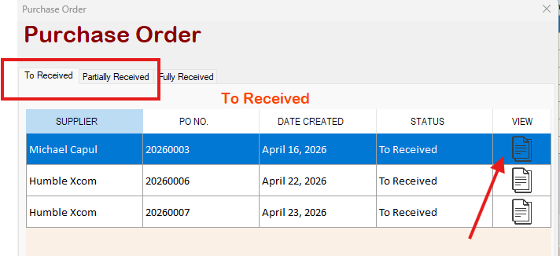
  - If continuing an incomplete transaction, go to the Partially Received tab instead.
- Select the Purchase Order you want to receive.
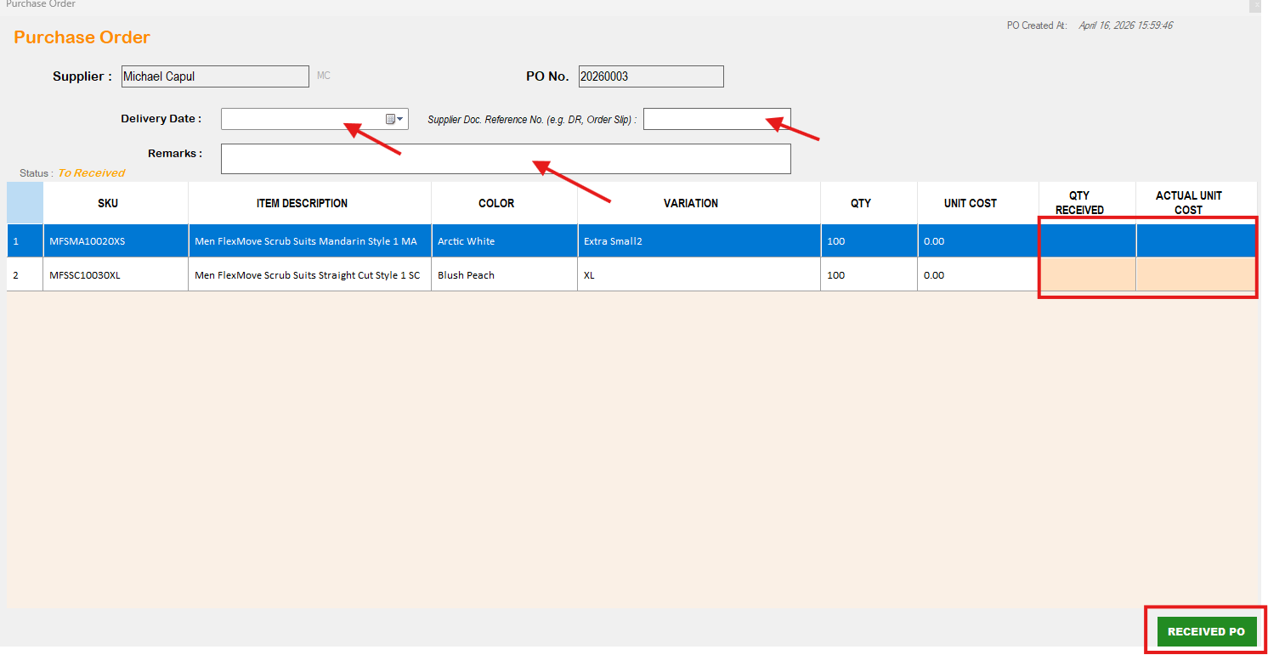
- Input necessary fields then enter the received quantity and actual unit cost for each item in the corresponding row.
- Review the entered details.
- Click the Received PO button to confirm.

Partial and Fully Received
- In the Partially Received tab, users can receive items multiple times until all quantities are fully completed.
Partial Receiving Process
    - Go to the Partially Received tab.
    - Select the Purchase Order (PO) want to receive again.
    - Follow the same receiving process.
    - Enter the remaining quantity for each item in the corresponding row.
    - Click the Receive / Submit button to confirm.
- Once all items are completely received, the Purchase Order will automatically move to the Fully Received status.
View Receiving History
This feature allows users to view the history of all received items, whether from Partially Received or Fully Received Purchase Orders.
To view the receiving history:
- Click the View History button below.
- Select Delivery Receipt.
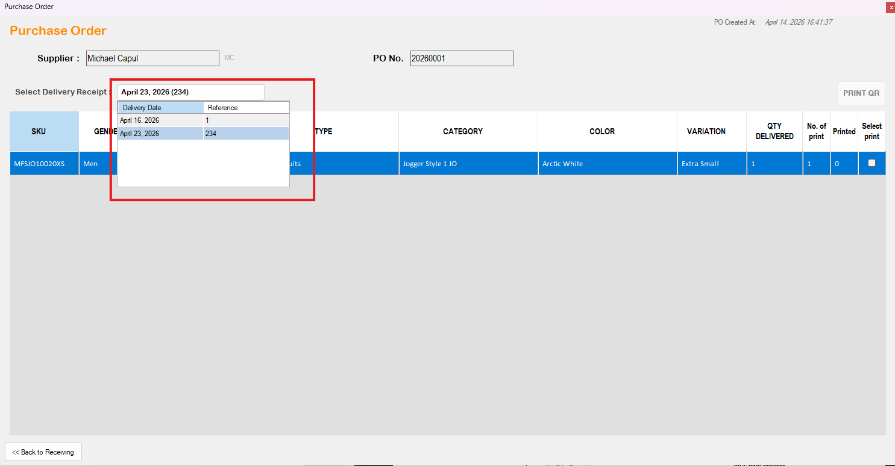
- The system will display all recorded receiving transactions.
- Users can review details such as items received, quantities, and receiving dates.
- Printing SKU Sticker
This feature allows users to print QR stickers for selected SKUs from the product list.
How to Print SKU QR Sticker via Product Tab Module > SKU.
- Go to the Product Tab Module.
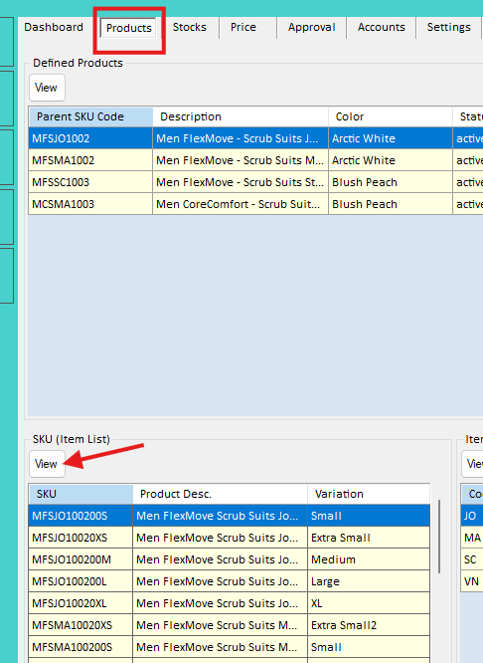
- Click the View button under SKU (Item List).
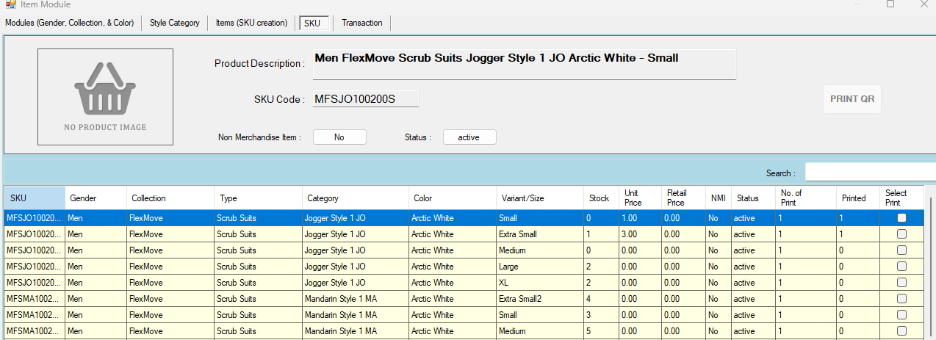
- The system will display the list of all items/SKUs.
- Select the items you want to print by ticking the checkbox in each row.
- In the No. of Print column, enter the number of copies for each SKU QR sticker.
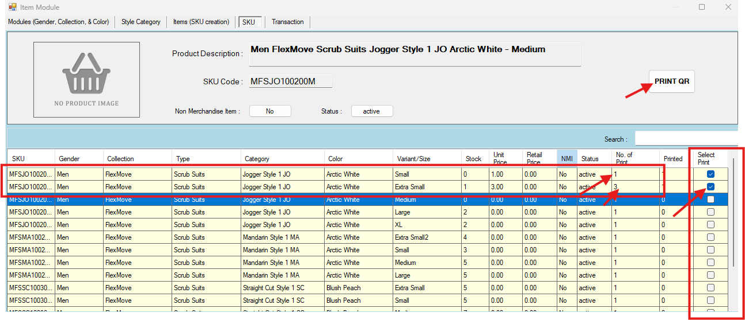
- Once selection and quantity are set, click the Print QR button.

The system will then generate and print the QR stickers based on the selected SKUs and specified number of copies.
Printing QR via Stock Module (Manual Purchase)
To print QR stickers from Manual Purchase records, follow these steps:
- Go to the Stocks Tab Module.
- Under the stock Data Grid, select the Manual Purchase tab.
- The system will display the history of manual purchase transactions.
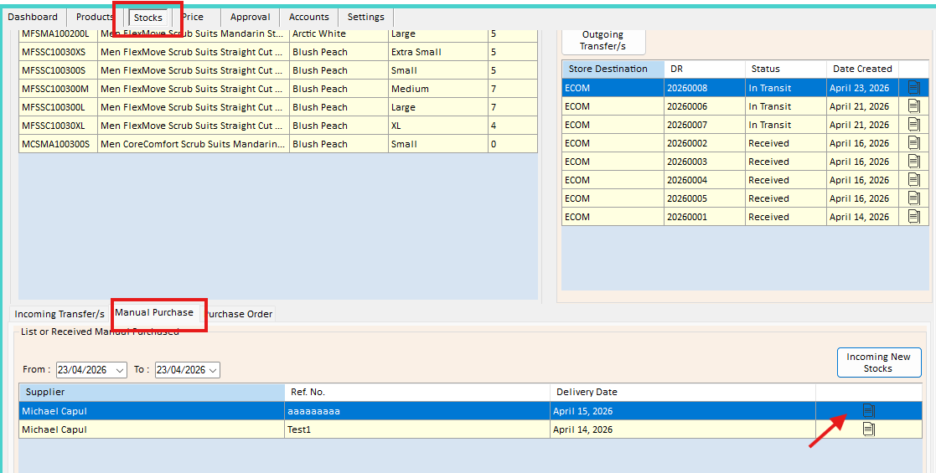
- Click the button in the row of the selected transaction to view the item list.
- In the item list, locate the No. of Print column.
- Enter the number of copies to print for each item.
- Tick the checkbox in the same row of the item you want to print.
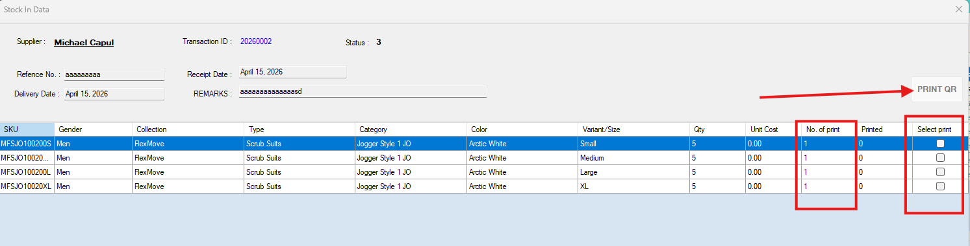
- Once selection is complete, click the Print QR button.

Printing QR via Stock Module (Purchase Order Receiving)
To print QR stickers from Purchase Order receiving records, follow these steps:
- Go to the Stock Tab Module.
- select the Purchase Order tab.
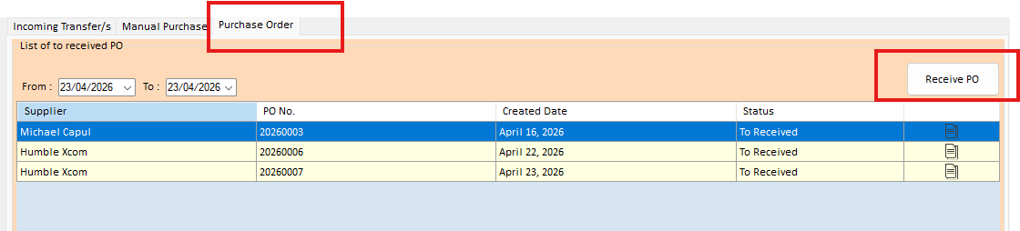
- Click the Receive PO button. A new form window will pop up.

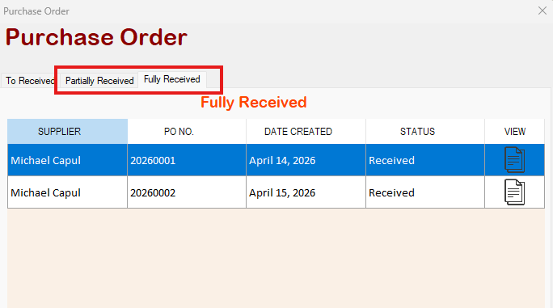
Accessing Receiving History
- In the PO Receiving window, go to either:
  - Partially Received tab, or
  - Fully Received tab
depending on the PO status.
- Select the Purchase Order by clicking the corresponding button in the row.
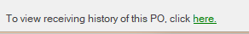
- Click the button below to view the receiving history details.
- Select Delivery Receipt.

Printing QR
- In the receiving history list, locate the No. of Print column.
- Enter the number of copies to print for each item.
- Input number of print then tick the checkbox in the same row of the item you want to print.
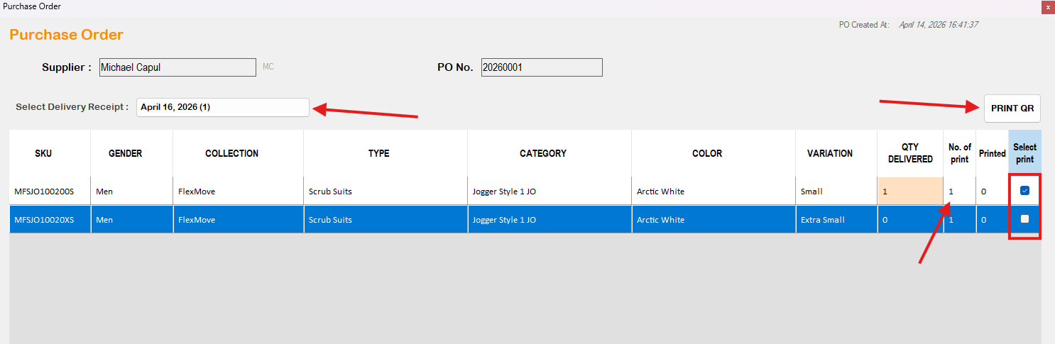
- Click the Print QR button to generate and print the QR stickers.

This will print QR stickers based on the selected receiving records and specified quantity.

- Printer Setup: Xprinter XP-470B
The Xprinter XP-470B is used for printing SKU QR code stickers. Follow the steps below to properly configure the printer.
Set as Default Printer
- On the Windows search bar, type “Printers & Scanners.”
- Open the Printers & Scanners settings.
- Select Xprinter XP-470B from the list of printers.
- Click Set as Default.
Configure Sticker Size
- Go to Printing Preferences of the Xprinter XP-470B.
- Navigate to the Page Setup tab.
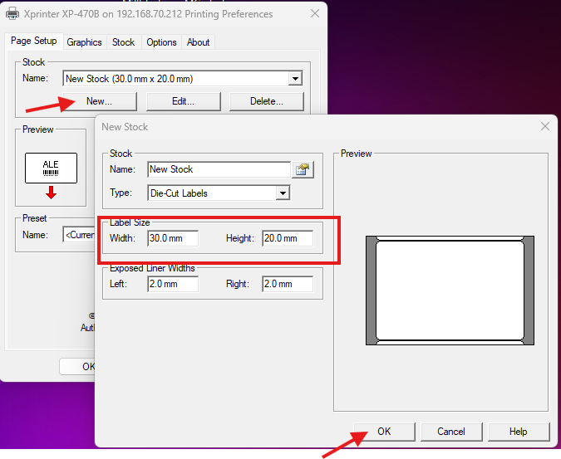
- Under Stock, click New to create a custom size.
- Set the following dimensions:
  - Width: 30 mm
  - Height: 20 mm
- Save the new stock size.
Set Orientation
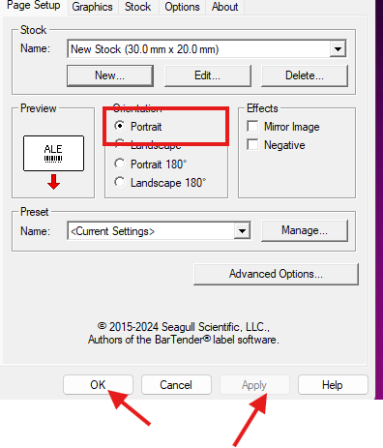
- In the same settings window, locate Orientation.
- Select Portrait.
- Click Apply, then OK.
Note: Ensure the sticker size matches your actual label roll to avoid misalignment when printing.

- Price Module
The Price Module allows users to view and manage product pricing within the system.
In this module, users can:
- View the Unit Price (cost or base price of the item)
- View the Retail Price (selling price of the item)
- Manually update product prices when necessary
This module ensures that all product pricing is accurate and up to date for inventory and sales operations.
How to Update Product Price
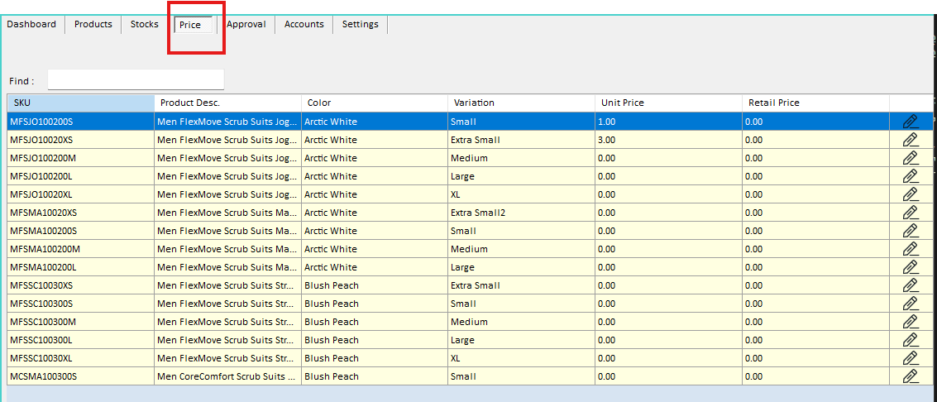
- Go to the Price Tab Module.
- Locate the item or SKU you want to update.
- Click the button in the same row of the selected item.
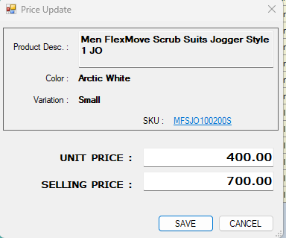
- Enter the new Unit Price and/or Retail Price.
- Save or confirm the changes.
Note
- Always double-check the correct item or SKU before updating prices to avoid errors.
- Ensure that the updated prices are accurate, as they may affect inventory valuation and sales transactions.

User Authority
The system uses authority codes to define user roles and access permissions.
Authority Codes
Code | Description
STK | Stock Clerk
RPT | Report
ADM | Administrator
OPE | Operator – System Maintenance
CAS | Cashier

Module Access
User access to system modules is based on assigned authority codes:
- STK (Stock Clerk) and ADM (Administrator)
  - Can access and manage the following modules:
    - Product Module
    - Stock Module
    - Price Module
- RPT (Report) and ADM (Administrator)
  - Approval Tab - Can approve transactions in the Store-to-Store Transfer Module

Administrator (ADM) Access and Responsibilities
The Administrator (ADM) has full system access and is responsible for managing system configurations, users, and key processes.
Administrative Functions
The Administrator can perform the following:
- RPT and STK Modules – Full access to the system.
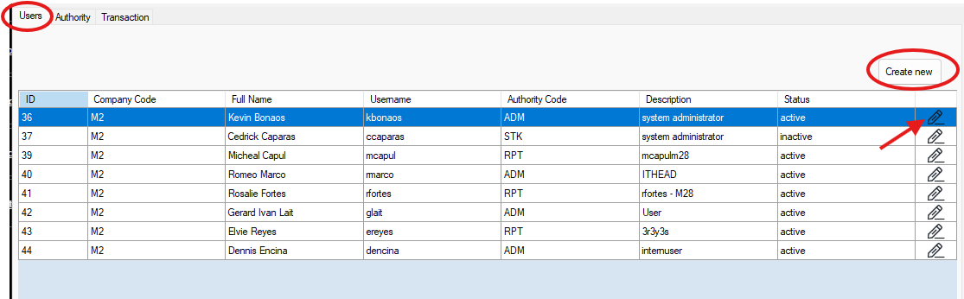
- User Management – Create, update, and manage user accounts and authority levels.
How to Create a New User
- Go to the Accounts Tab.
- Under Users, click the View button.
- Click the Create New User button.
- Fill in the required user details (e.g., name, username, password, and authority level).
- Click Submit to create the user account.
How to Update an Existing User
- Go to the Accounts Tab.
- Under Users, click the View button.
- Locate the user you want to update.
- Click the Update/Edit button in the same row.
- Modify the necessary user details or authority level.
- Click Submit to apply the changes.

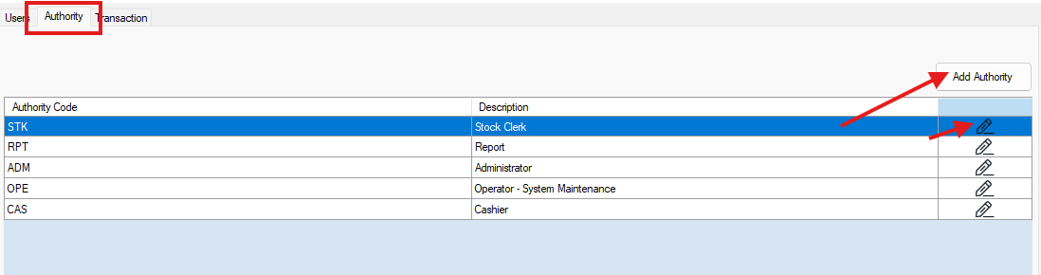
- Authority Management – Assign and modify user roles and permissions.
How to Create Authority
- Go to the Accounts Tab.
- Under Authority, click the View button.
- Click the Add Authority button.
- Enter the required details:
  - Authority Code
  - Description
- Click Submit to create the new authority.
How to Update Authority
- Go to the Accounts Tab.
- Under Authority, click the View button.
- Locate the authority you want to update.
- Click the Update/Edit button in the same row.
- Modify the authority description or other details as needed.
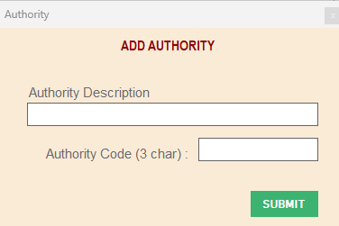
- Click Submit to apply the changes.

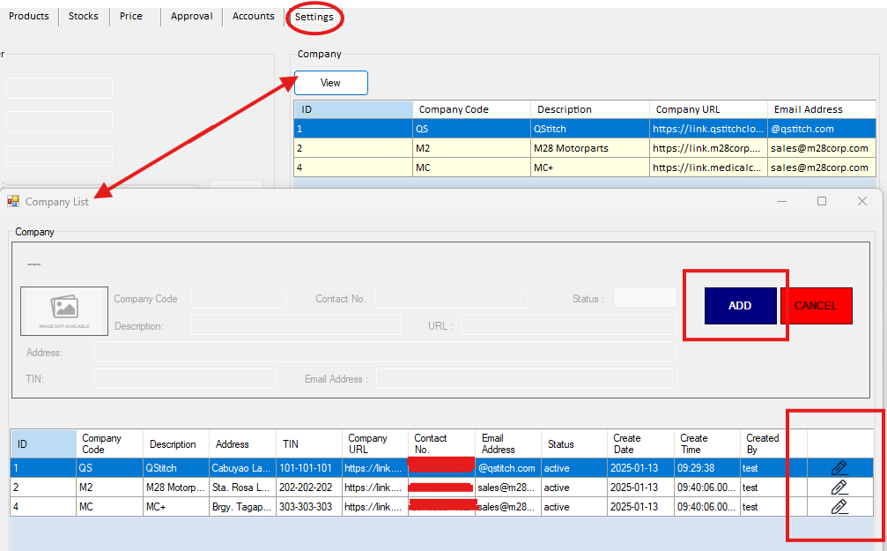
- Company Setup – Manage company information.
- Store Management – Add or update store/warehouse details (in database and not yet in the system).
- Database Configuration – Update and maintain database connection settings.
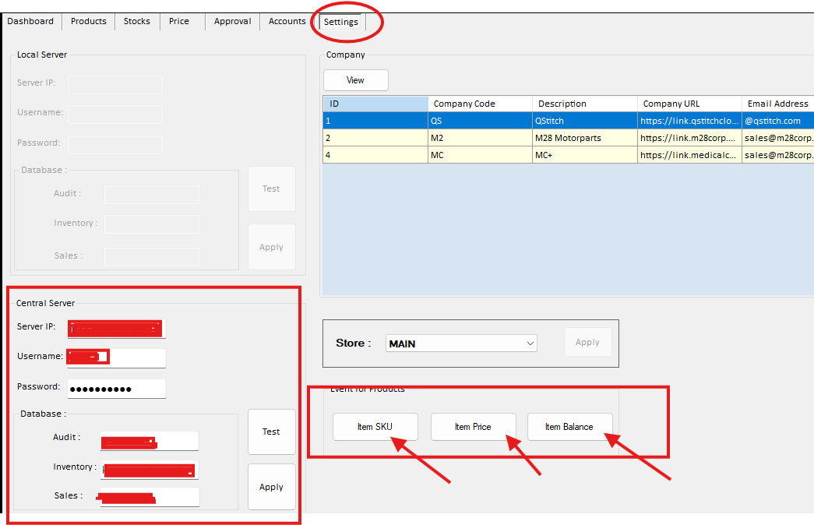
- System Events Triggering – Allows the Administrator to manually trigger system processes to update data in the SKU List, Item Price, and Item Balance modules.

